Cardinal Numbers and Ordinal Numbers
Cardinal numbers and ordinal numbers are explained here with the help of colorful pictures.
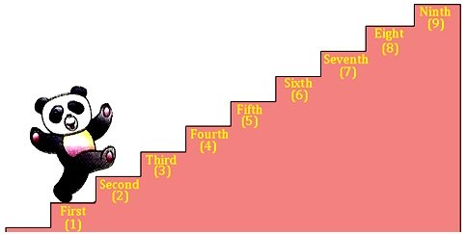
There are many steps in a staircase as shown in the above figure. The given staircase has nine steps, i.e., 1, 2, 3, 4, 5, 6, 7, 8 and 9.
Cardinal numbers
showing serial number ⇒ 1 2 3 4 5 6 7 8 9
of steps of staircase
Ordinal numbers
from the front ⇒ 1st 2nd 3rd 4th 5th 6th 7th 8th 9th

